PROJECT HUMAN RESOURCE AND STAKE HOLDER ASSIGNMENT PROJECT REPORT.



TEAM MEMBER NAMES:
COURSE CODE: HRM 4200
PROFESSOR’S NAME:
SECTION:
DATE: 9/08/2019

TABLE OF CONTENT
    - INTRODUCTION.............................................................
    - STAKEHOLDER ANALYSIS...............................................
    - STAKEHOLDER REGISTER...............................................
    - STAKEHOLDER ENGGAGEMENT PLAN...........................
    - PROJECT TEAM ORGANIZATIONAL STRUCTURE............
    - HUMAN RESOURCE PLAN..............................................

1. INTRODUCTION.
The document is created to demonstrate the inputs of the above-mentioned course on the students. The project that will be analyzed in this report is An Applied project, undertaken by Arshdeep Singh and his project team, the Project title was Fill the Shelves which involved the project team planning and executing activities to raise funds for the Algonquin food cupboard headed by Jessica Clark. Each members of the team were assigned with various responsibilities on the project as the planning stage came to an end, the document will outline the various stakeholders on the project, analyze them and plan according to the requirement stated for this report.
As indicated in the table of content the document will address various components of the Human resource and stake holder report that will pertain to the FILL THE SHELVES project that was carried out during the term.

2. STAKEHOLDER ANALYSIS.
Using the POWER- INTEREST grid model for the Stake Holder analysis, to be able to understand how to engage stake holder groups based on their interest.

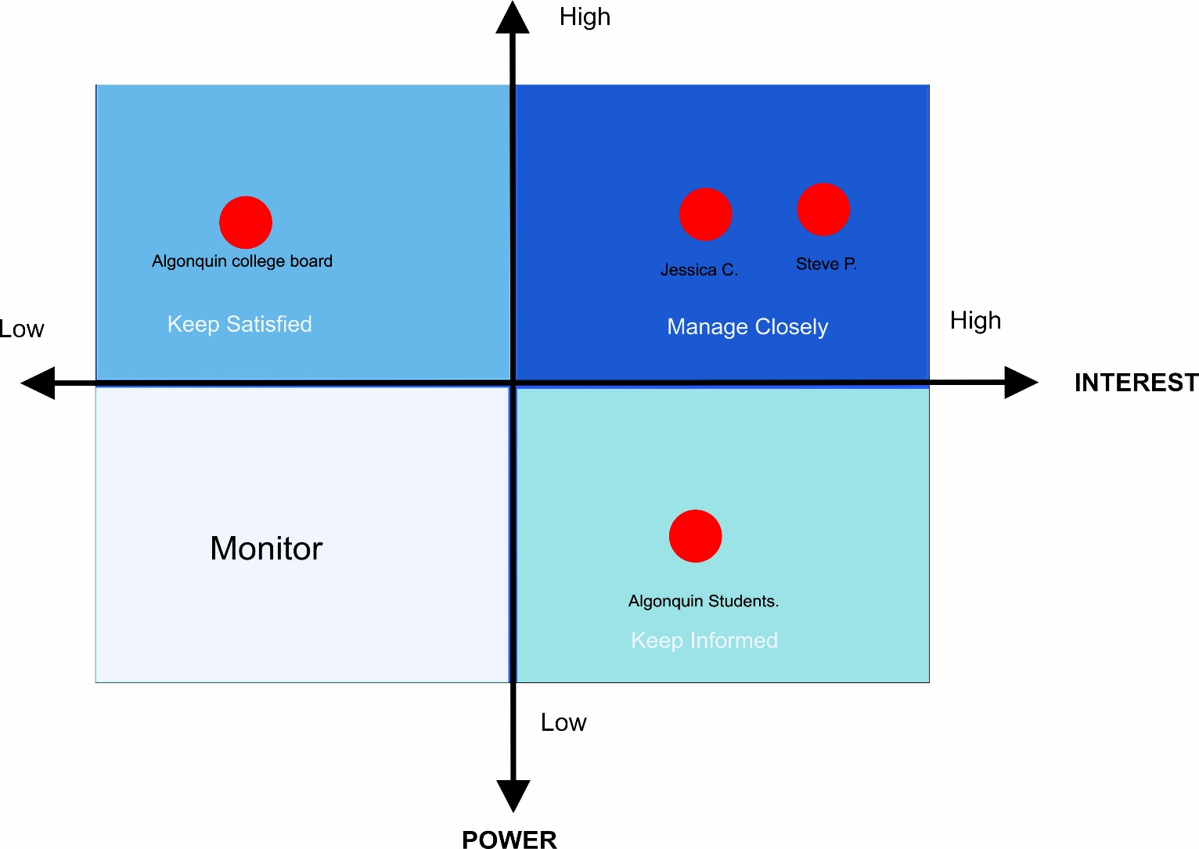

3. STAKEHOLDER REGISTER

stakeholder name | role in the project | CONTACT INFORMATION | key EXPECTATIONS | POTENTIAL LEVEL OF INFLUENCE (H/M/L) | CLASSIFICATION (INTERNAL OR EXTERNAL) | notes
Jessica Clark | Sponsor |  |  | H | Internal
Steve Putman | Sponsor | putmans@algonquincollege.com |  | H | Internal
Algonquin college Board | Silent  Executive | www.algonquincollege.com |  | M | Internal
Algonquin Students | Beneficiary |  |  | L | Internal
Donor’s | Secondary sponsor |  |  | H | External
Saeed Buryam | Project manager | bura0012@algonquinlive.com |  | H | Internal
Arshdeep Singh | Procurement manager | Sing1127@algonquinlive.com |  | M | Internal
Qiong lin | Fundraiser | lin00142@algonquinlive.com |  | M | Internal
Geetanjali | Fundraiser | geet0002@algonquinlive.com |  | M | Internal
Sandeep Kumar | Finance | kuma0142@algonquinlive.com |  | H | Internal
Aithel Shibu | Finance | shib0017@algonquinlive.com |  | H | Internal

4. Stakeholder Engagement PLAN

stakeholder name | role in the project | LEVEL OF INFLUENCE (H/M/L) | INFLUENCE TYPE (SUPPORTER, RESISTER, OR NEUTRAL) | level of interest (h/m/l) | current engagement level | engagement strategy
Jessica Clark | Sponsor | H | SUPPORTER | H | Supportive | By inviting the sponsor in Kick-off meeting to participate in that. Build a strong working relationship and by regularly reporting on the project status.
Steve Putman | Sponsor | H | SUPPORTER | H | Supportive | By inviting the sponsor in Kick-off meeting to participate in that. Build a strong working relationship and by regularly reporting on the project status.
Algonquin college Board | Host of the general project | M | NEUTRAL | M | Neutral | Make information available to the stakeholder by communication like e-mails.
Algonquin Students | Beneficiaries | L | NEUTRAL | L | Unaware | Sharing the information with them by letters, videos, pamphlets to make aware them.
Donor’s | Secondary sponsors | H | SUPPORTER | L | Supportive | Research for the donor’s and Create a balanced communication with your donors and try to connect with them through social media.
Arshdeep Singh | Procurement manager | M | SUPPORTER | H | Leading | By sharing the accountability of the work and giving responsibility will motivate them
Qiong lin | Fundraiser | H | SUPPORTER | M | Supportive | Getting Regular updates through text and weekly meeting with to motivate them.
Geetanjali | Fundraiser | L | RESISTER | L | Resistant | Getting Regular updates through text and weekly meeting with to motivate them.
Sandeep kumar | Finance | M | NEUTRAL | H | Neutral
Aithel Shibu | Finance | H | SUPPORTER | H | Supportive

5. PROJECT ORGANIZATIONAL STRUCTURE WITH ROLES AND RESPONSIBILITIES.

